BCB 570 HW2

Urminder Singh

January 21, 2018

Q1)



a) let D(N) be the degree of node N then,

D(r)=4

D(s)=2

D(t)=3

D(u)=2

D(v)=4

D(w)=4

D(x)=4

D(y)=4

D(z)=5

Degree distribution for 0<k<6

P(k=1) =0

P(k=2) =2/9

P(k=3) =1/9

P(k=4) =5/9

P(k=5) =1/9

b) let C(N) be the clustering coefficient of node N then using formula for clustering coeff.



C(r) = ½

C(s) = 1

C(t) = 2/3

C(u) = 1

C(v) = ½

C(w) = ½

C(x) = ½

C(y) = 2/3

C(z) = 2/5

Distribution of clustering coefficient vs degree (k)

Q2



a)

DFS starting at node w with lexicographic and reverse order

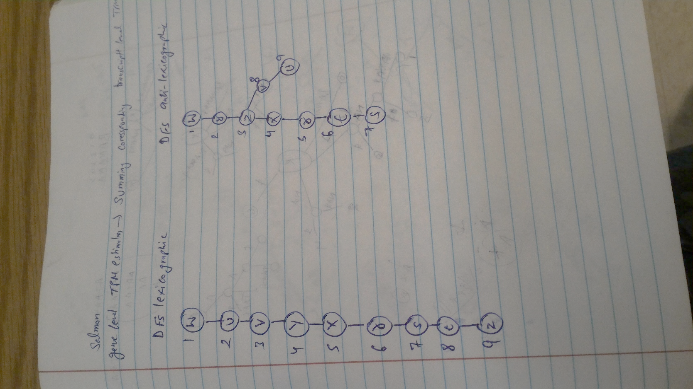

DFS starting at node s with lexicographic and reverse order

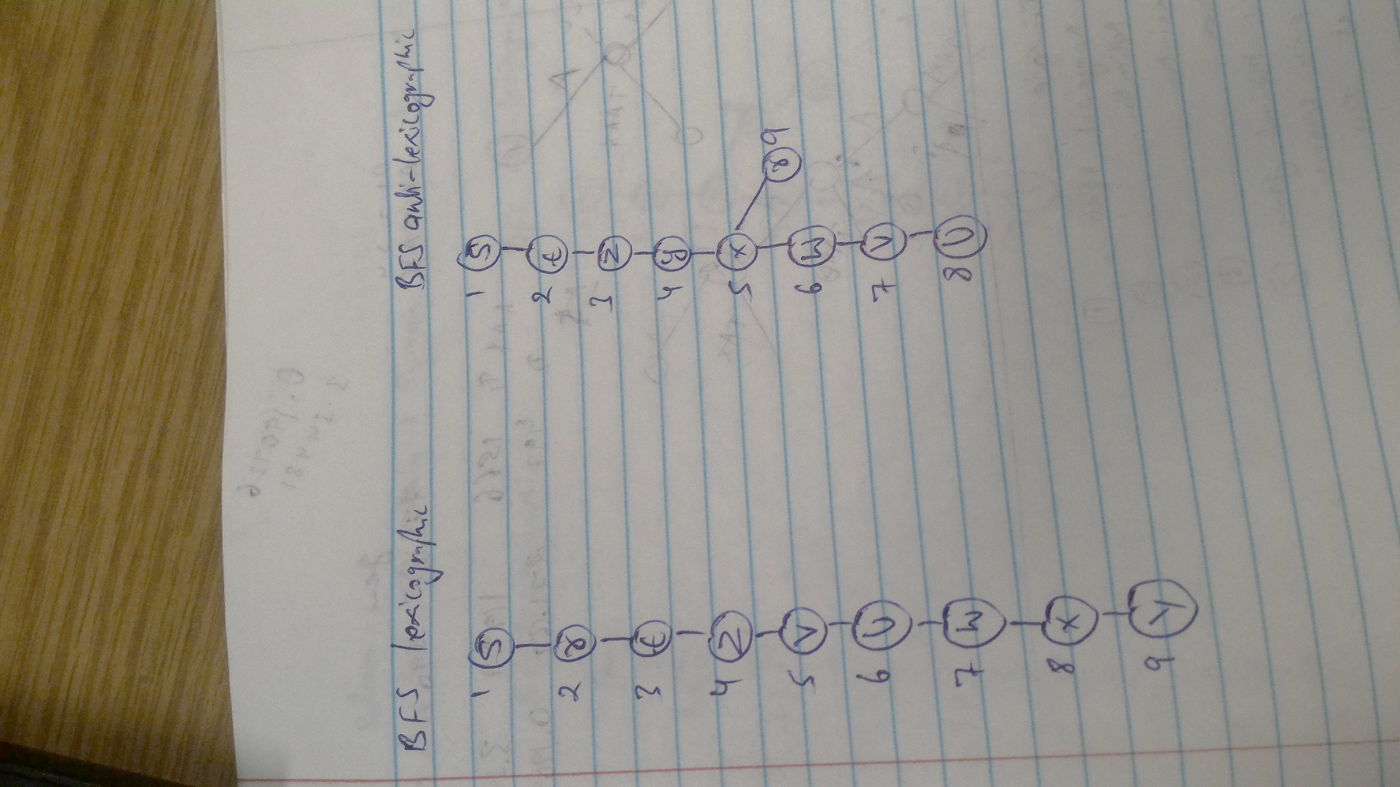

Ans 3)

BFS starting at node w with lexicographic and reverse order

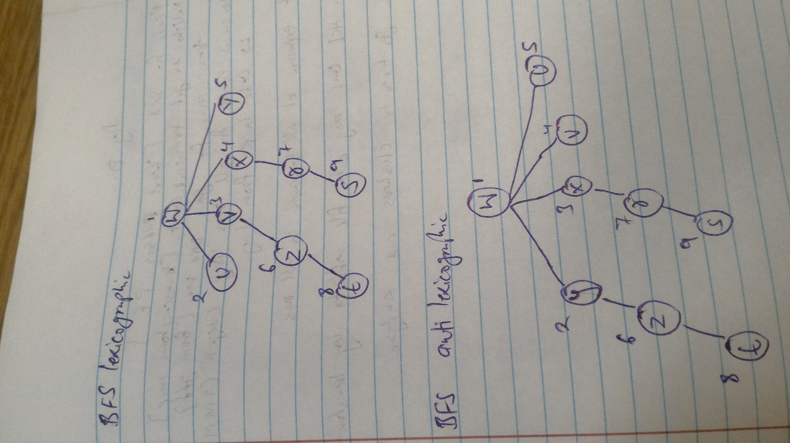

BFS starting at node s with lexicographic and reverse order

